PROJECT REPORT

PROJECT TITLE
ONLINE PAYMENTS FRAUD DETECTION USING MACHINE LEARNING
COLLEGE NAME
ANNAMACHARYA INSTITUTE OF TECHNOLOGY AND SCIENCES, TIRUPATI
TEAM MEMBERS
        - VAISHNAVI SRAVANTHI PATURU (Team Leader)
- sravanthipaturu279@gmail.com
        - BATTI YASMIN (Team Member)
-
        - K HEMA MADHURI (Team Member)
-

1.INTRODUCTION

1.1 PROJECT OVERVIEW
The Online Payment Fraud Detection System using Machine Learning is an advanced solution developed to identify fraudulent activities in digital financial transactions. With the rapid growth of e-commerce, online banking, and digital payment platforms such as UPI, credit/debit cards, and mobile wallets, the number of online transactions has increased significantly. This growth has also led to a rise in cyber fraud, making fraud detection a critical requirement for financial systems.
Traditional fraud detection systems are mostly rule-based, where predefined rules are used to identify suspicious transactions. However, these systems are not efficient in detecting new or evolving fraud patterns, as fraudsters continuously adapt their techniques. To overcome these limitations, this project implements a machine learning-based approach that can learn from historical transaction data and identify complex patterns that indicate fraudulent behaviour.
The system works by collecting transaction data such as transaction amount, time, location, frequency, and user behaviour. This data is then pre-processed and fed into a machine learning model that has been trained on labelled datasets containing both fraudulent and legitimate transactions. The model analyses the input data and predicts whether a transaction is genuine or fraudulent.
Key features of the system include:
- Real-time fraud detection using trained ML models
- Pattern recognition and anomaly detection
- Automated decision-making without human intervention
- Scalability to handle large volumes of transactions
- Improved accuracy compared to traditional methods
This project demonstrates how machine learning can be effectively applied in the financial domain to enhance security and reduce fraud risks.

1.2 PURPOSE
The primary purpose of this project is to design and develop an intelligent fraud detection system that can automatically identify suspicious online transactions and prevent financial fraud. The project aims to leverage machine learning techniques to build a system that is not only accurate but also adaptive to new fraud patterns.
The detailed objectives of the project are as follows:
1. Enhance Transaction Security
One of the main goals is to improve the overall security of online payment systems by detecting fraudulent activities before they cause significant damage. The system helps protect users’ financial data and prevents unauthorized transactions.
2. Detect Fraud in Real-Time
The project aims to provide real-time analysis of transactions. As soon as a transaction is initiated, the system evaluates it and immediately classifies it as legitimate or fraudulent, enabling quick action such as blocking the transaction or sending alerts.
3. Reduce Financial Losses
Fraudulent transactions result in major financial losses for both users and financial institutions. By accurately detecting fraud, the system minimizes these losses and ensures safer transactions.
4. Automate Fraud Detection Process
Manual monitoring of transactions is time-consuming and inefficient. This project eliminates the need for constant human supervision by automating the detection process using machine learning models.
5. Adapt to Evolving Fraud Patterns
Fraudsters continuously change their methods to bypass security systems. The machine learning model used in this project can learn from new data and update itself, making it capable of detecting new types of fraud.
6. Improve Accuracy and Efficiency
The system is designed to achieve high accuracy with minimal false positives (legitimate transactions flagged as fraud) and false negatives (fraud transactions not detected), ensuring reliability.
7. Provide a Scalable Solution
The system is capable of handling a large volume of transactions, making it suitable for real-world applications such as banking systems, e-commerce platforms, and payment gateways.

2. IDEATION PHASE

2.1 PROBLEM STATEMENT
Problem Statement:
The Customer Problem Statement template is used to understand the challenges faced by users in online payment systems, especially related to fraud detection. It helps the team focus on critical issues such as security, accuracy, and user trust while designing the solution.
A well-defined customer problem statement enables the team to identify risks in digital transactions, understand user concerns about fraud, and develop an effective machine learning-based system to detect suspicious activities. It also helps in empathizing with both customers and financial institutions, ensuring the system is reliable, fast, and user-friendly.
By clearly understanding these problems, the team can design a solution that minimizes fraud, reduces false alerts, and improves overall user confidence in online payment platforms.

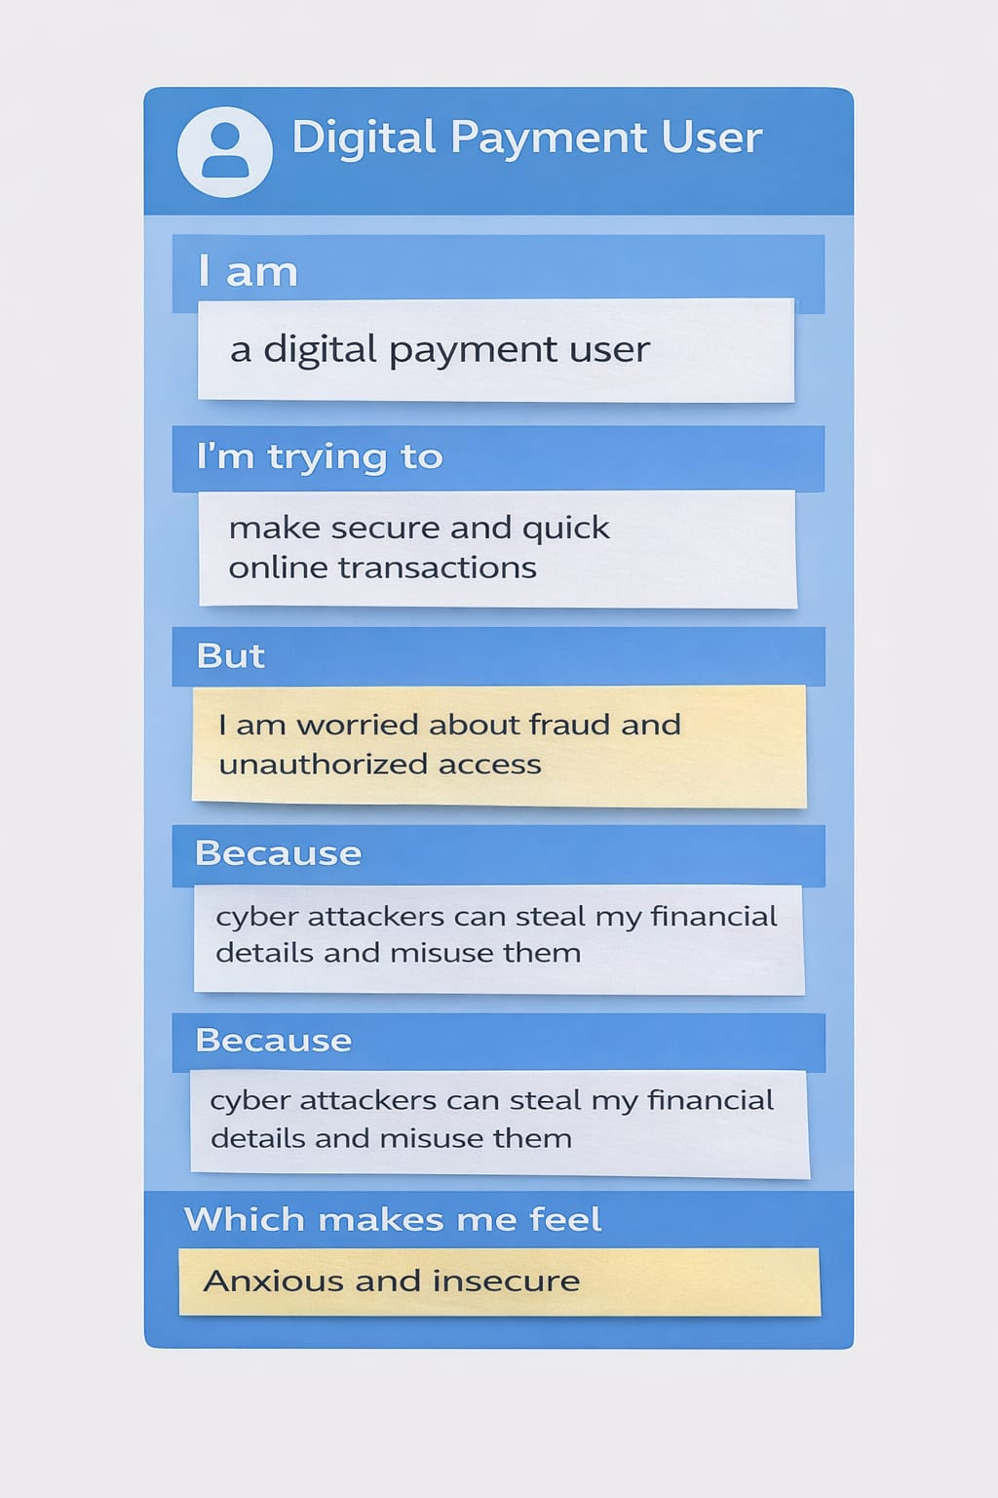

EXAMPLE
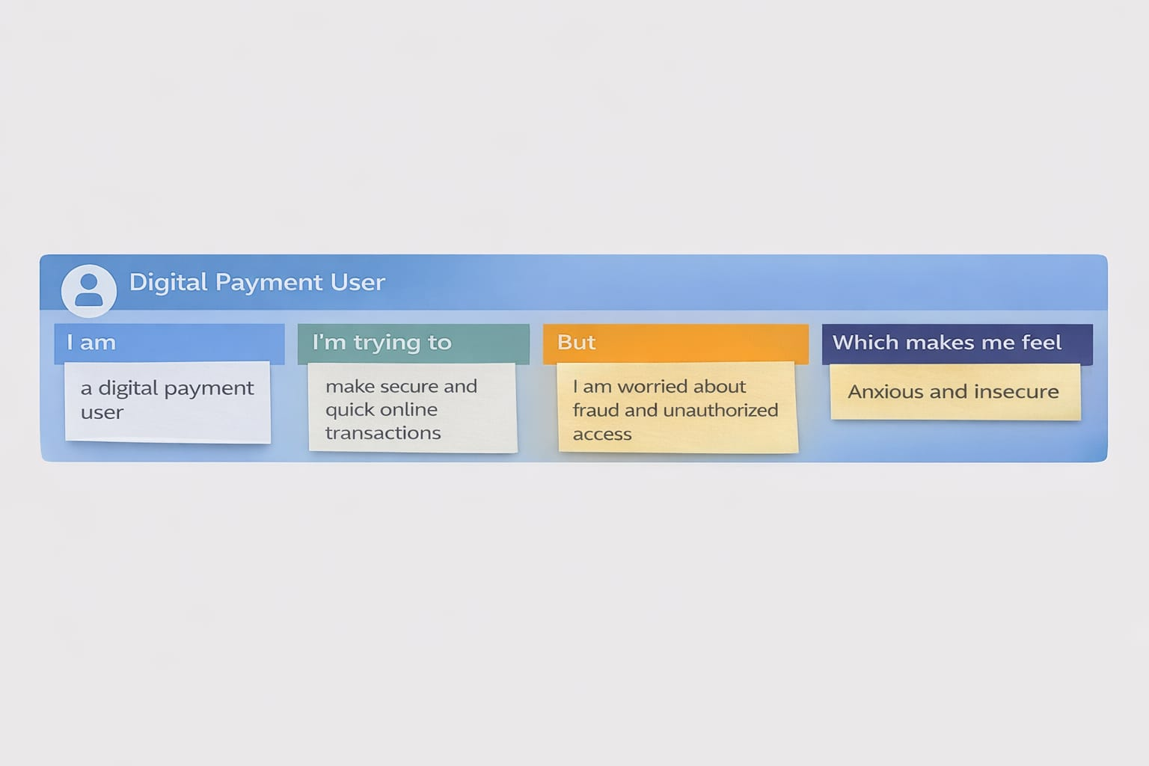

Problem Statement (PS) | I am (Customer) | I’m trying to | But | Because | Which makes me feel
PS-1 | I am an online banking user | I’m trying to make secure digital payments | But I am worried about fraud and unauthorized transactions | Because cybercriminals can misuse my financial details | Which makes me feel anxious and unsafe
PS-2 | I am a bank/payment service provider | I’m trying to detect fraudulent transactions accurately | But traditional systems fail to detect new fraud patterns | Because they rely on fixed rules and lack adaptability | Which makes me feel challenged in ensuring customer trust

2.2 EMPATHY MAP CANVAS
Empathy Map Canvas:
An empathy map is a simple visual tool used to understand the thoughts, feelings, behaviours, and challenges of users in online payment systems. It helps identify key concerns such as fear of fraud, unauthorized transactions, and lack of trust in digital payments.
By analysing user experiences, the team can better understand their needs and expectations, which supports the development of a secure and reliable machine learning-based fraud detection system. This ensures improved accuracy, reduced risks, and enhanced user confidence.
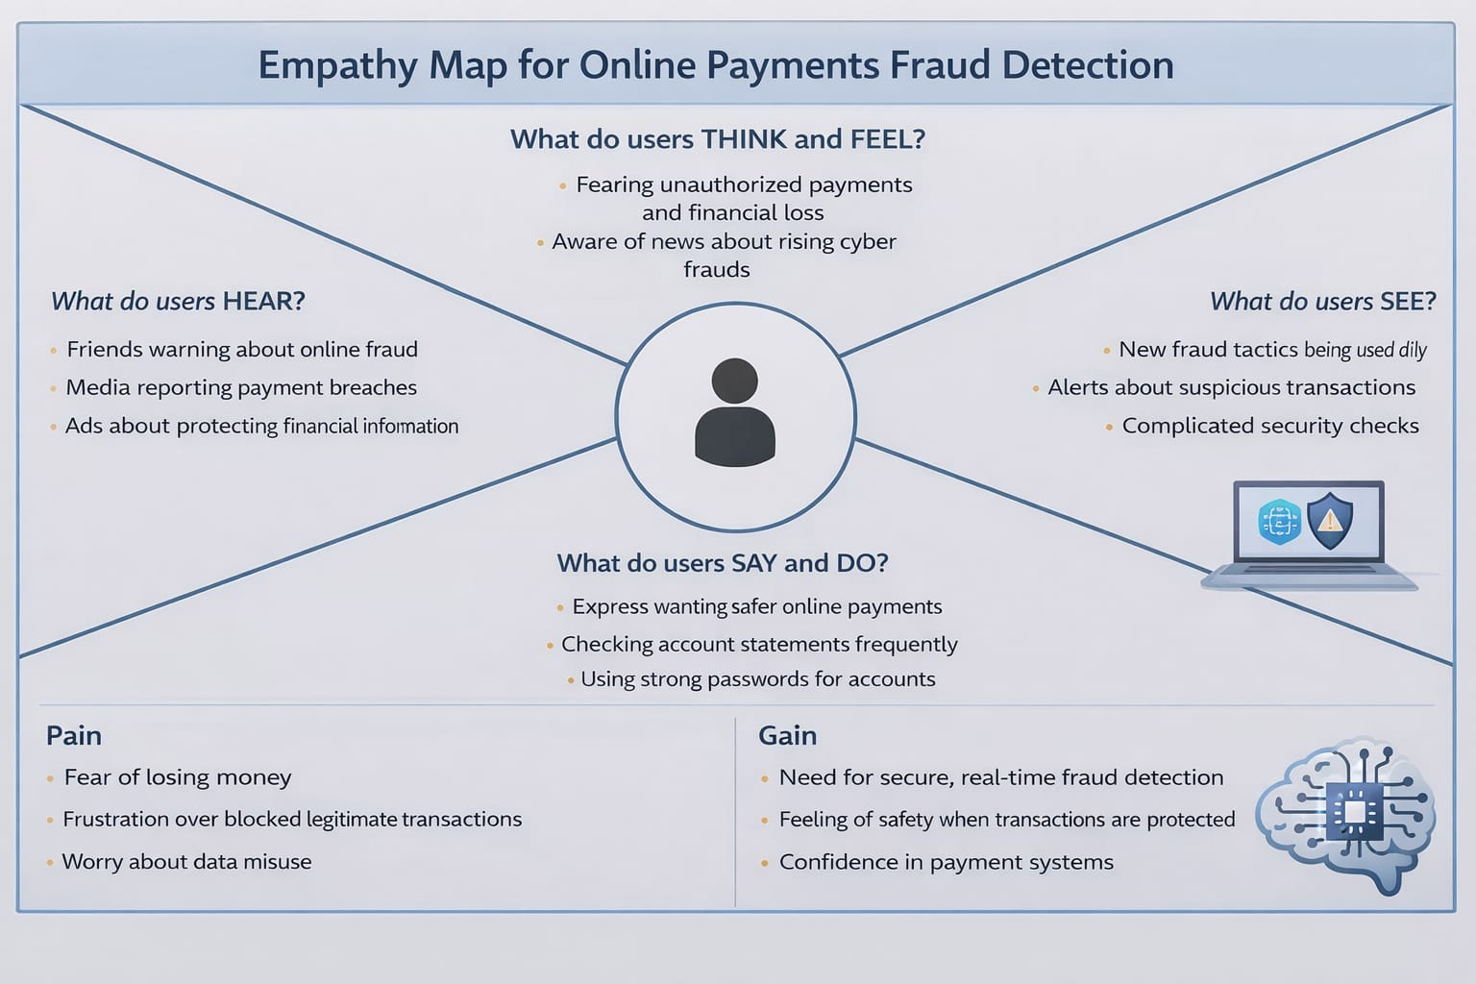

2.3 BRAINSTORMING
Brainstorm & Idea Prioritization Template:
Brainstorming provides a free and open environment that encourages everyone within a team to participate in the creative thinking process that leads to problem solving. Prioritizing volume over value, out-of-the-box ideas are welcome and built upon, and all participants are encouraged to collaborate, helping each other develop a rich number of creative solutions.

Step-1: Team Gathering, Collaboration and Select the Problem Statement
Team Members:
Team Leader: Vaishnavi Sravanthi P
Team Member: Batti Yasmin
Team Member: K Hema Madhuri
Discussion Summary
- Discussed increasing fraud in digital payment systems
- Identified challenges in detecting real-time fraudulent transactions
- Reviewed existing systems (rule-based detection limitations)
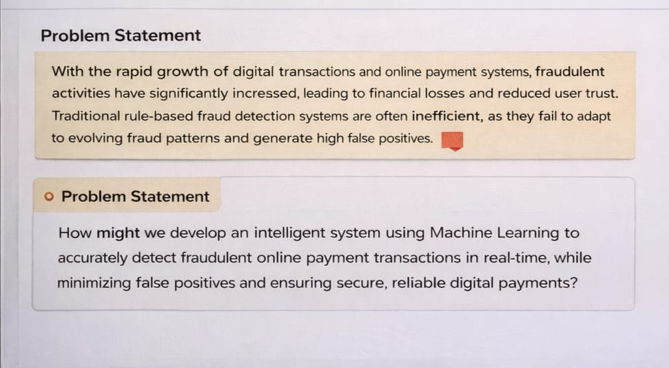

Step-2: Brainstorm, Idea Listing and Grouping
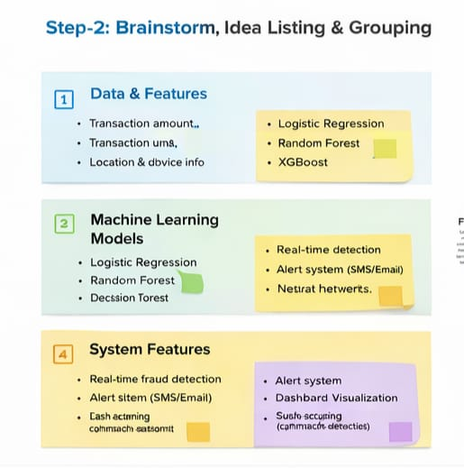

Step-3: Idea Prioritization
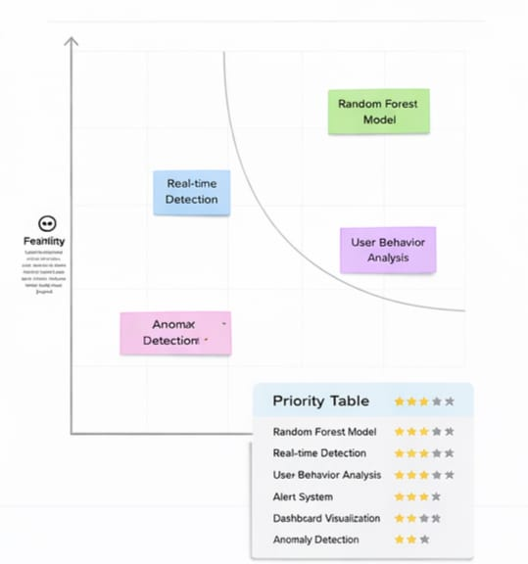

3. REQUIREMENT ANALYSIS

3.1 CUSTOMER JOURNEY MAP

🧭 Customer Journey Map
👤 User Persona
Customer (Online Payment User)
Goal: Make secure and quick online transactions without fraud.
📊 Journey Stages
Stage
User Actions
Thoughts
Pain Points
System Response
1. Awareness
Opens payment app / website
"I need to make a payment"
Fear of fraud
Secure login system
2. Login
Enters credentials
"Is my account safe?"
Phishing risk
Authentication & encryption
3. Initiate Payment
Enters card/UPI details
"Hope this is secure"
Data theft concerns
Input validation
4. Transaction Processing
Confirms payment
"Will this go through safely?"
Fraud uncertainty
ML fraud detection model runs
5. Fraud Check
System analyzes behavior
"Why is it taking time?"
Delay frustration
Risk scoring & anomaly detection
6. Decision
Transaction approved/blocked
"Was this flagged wrongly?"
False positives
Alerts & verification
7. Notification
Receives confirmation/alert
"Good, it's secure"
Confusion if blocked
Real-time alerts
8. Post-Transaction
Reviews transaction history
"Everything looks fine"
Lack of transparency
Transaction logs & reports

CUSTOMER JOURNEY MAP:

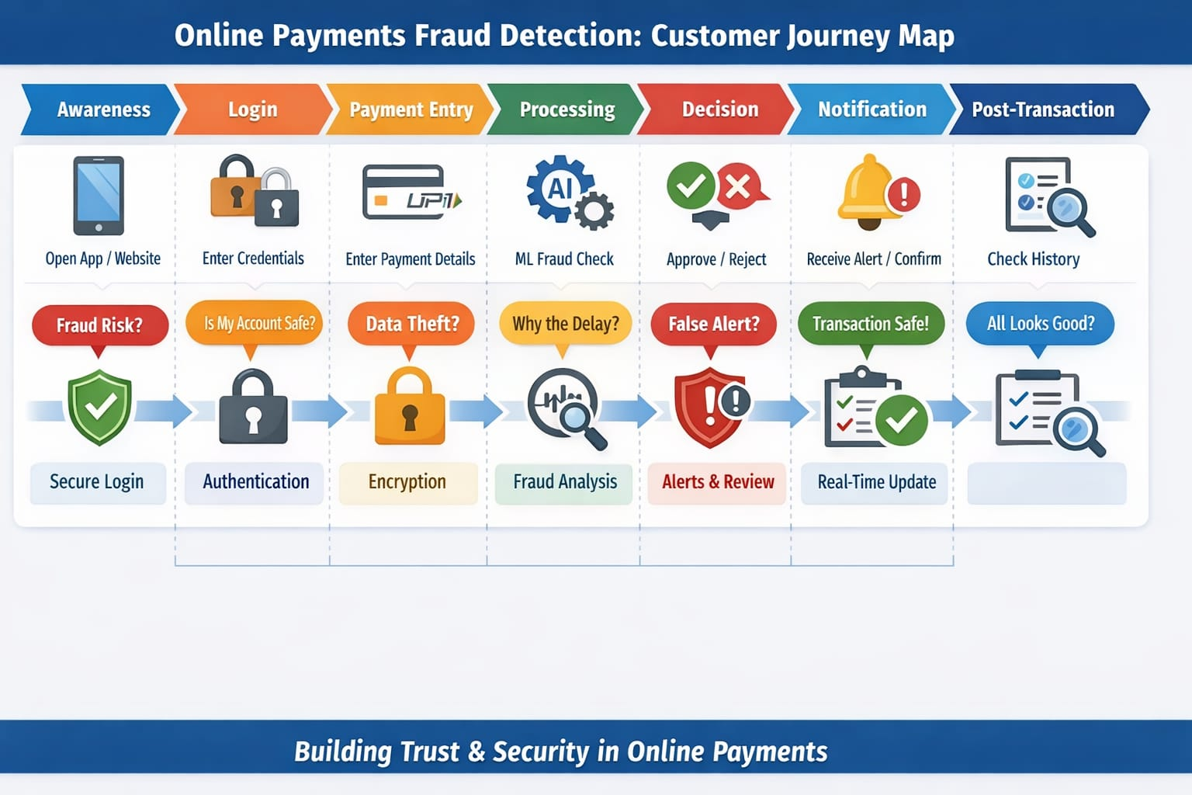

3.2 SOLUTION REQUIREMENT
Functional Requirements:
Following are the functional requirements of the proposed solution.
FR No. | Functional Requirement (Epic) | Sub Requirement (Story / Sub-Task)
FR-1 | User Registration | Registration through form (email, password)
 |  | Registration via OTP verification
FR-2 | User Login | Login using email & password
 |  | Secure login using OTP / 2FA
FR-3 | Transaction Processing | User initiates online payment
 |  | Capture transaction details (amount, device, location)
FR-4 | Fraud Detection System | Analyze transactions using ML model
 |  | Classify transaction as fraud or legitimate
FR-5 | Alert & Notification | Send fraud alerts to users
 |  | Notify successful transactions

Non-functional Requirements:
Following are the non-functional requirements of the proposed solution.
NFR No. | Non-Functional Requirement | Description
NFR-1 | Usability | System should be user-friendly and easy to navigate
NFR-2 | Security | Ensure secure transactions using encryption & authentication
NFR-3 | Reliability | System should accurately detect fraud with minimal errors
NFR-4 | Performance | Real-time fraud detection with low latency
NFR-5 | Availability | System should be available 24/7 without downtime
NFR-6 | Scalability | Handle large volume of transactions efficiently

3.3 DATA FLOW DIAGRAM
Data Flow Diagrams:
A Data Flow Diagram (DFD) is a traditional visual representation of the information flows within a system. A neat and clear DFD can depict the right amount of the system requirement graphically. It shows how data enters and leaves the system, what changes the information, and where data is stored.
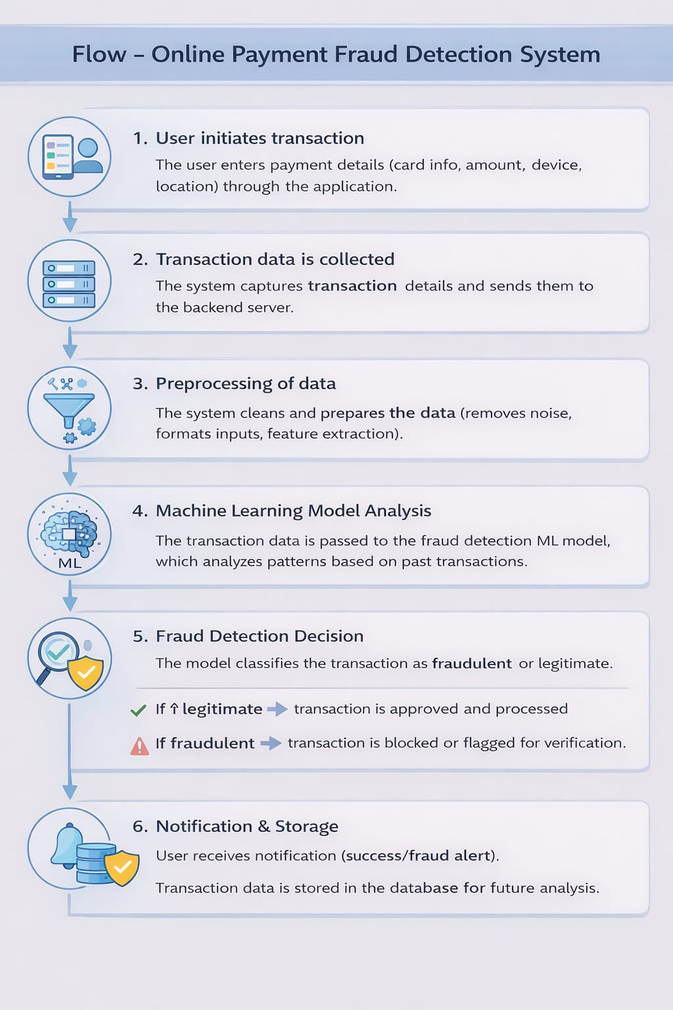
LEVEL 0 DFD
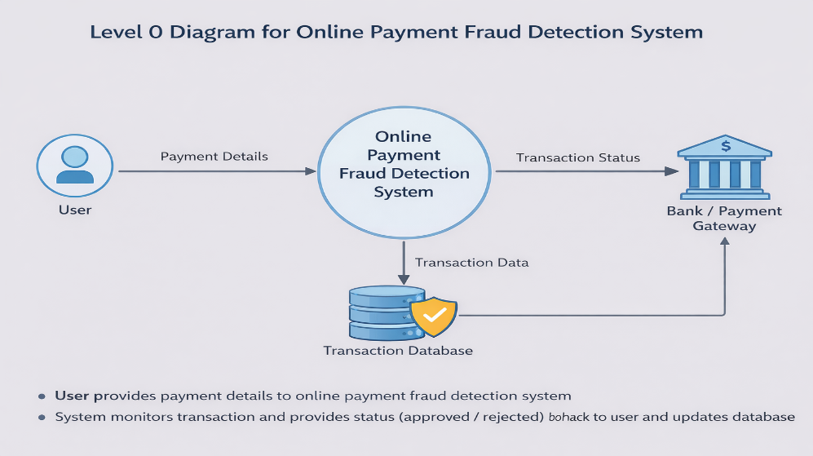

3.4 TECHNOLOGY STACK
Technical Architecture:
The Deliverable shall include the architectural diagram as below and the information as per the table1 & table 2
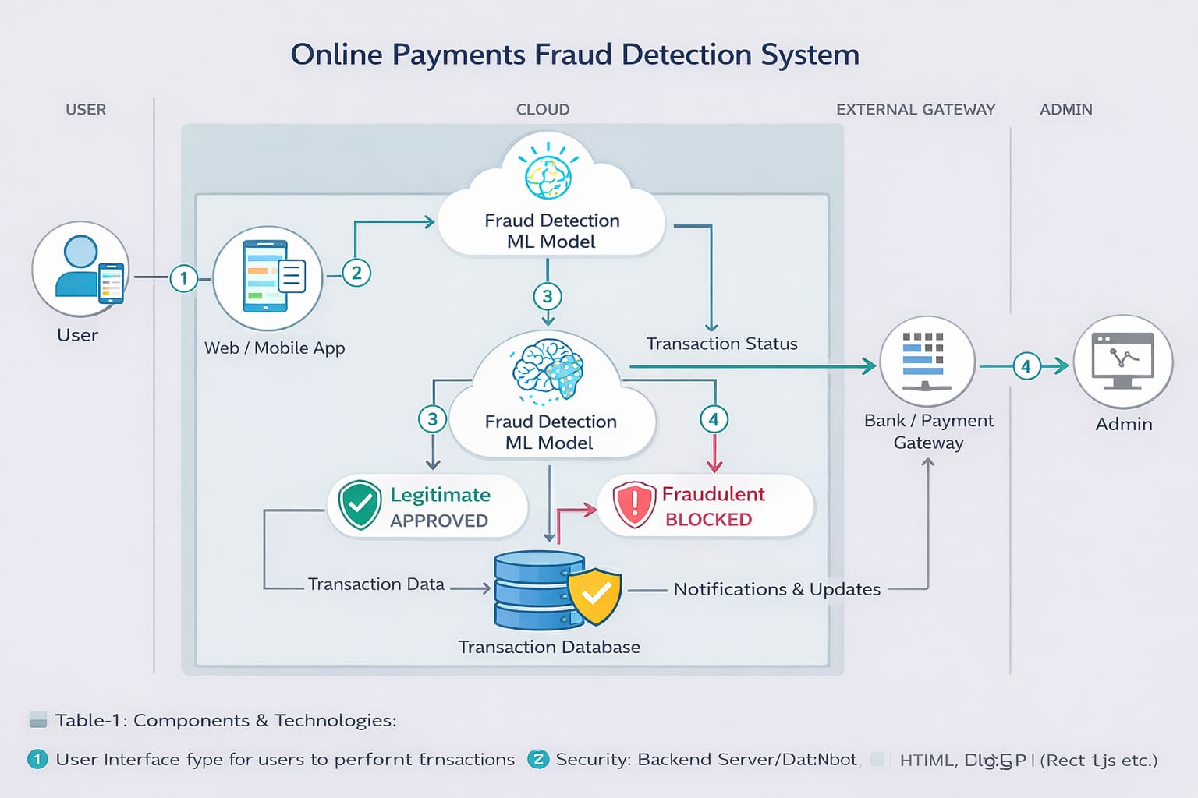
Table-1 : Components & Technologies:
S.No | Component | Description | Technology
1 | User Interface | Web/mobile interface for users to perform transactions | HTML, CSS, JavaScript, React
2 | Application Logic-1 | Handles user authentication & transaction processing | Python (Flask / Django)
3 | Application Logic-2 | Data preprocessing & feature extraction | Python (Pandas, NumPy)
4 | Application Logic-3 | Fraud detection using ML model | Scikit-learn / TensorFlow
5 | Database | Stores user and transaction data | MySQL / PostgreSQL
6 | Cloud Database | Scalable storage for large transaction datasets | Firebase / AWS RDS
7 | File Storage | Stores logs, datasets, and model files | Local Storage / AWS S3
8 | External API-1 | Payment gateway integration | Razorpay / Stripe API
9 | External API-2 | OTP / Notification services | Twilio / Firebase OTP
10 | Machine Learning Model | Detects fraudulent transactions | Logistic Regression / Random Forest
11 | Infrastructure (Server/Cloud) | Deployment environment | AWS / Azure / Local Server

Table-2: Application Characteristics:
S.No | Characteristics | Description | Technology
1 | Open-Source Frameworks | Used for backend and ML model development | Flask, Django, Scikit-learn
2 | Security Implementations | Data encryption, authentication, fraud protection | SSL, SHA-256, JWT, OAuth
3 | Scalable Architecture | System supports increasing users & transactions | Microservices, Cloud Deployment
4 | Availability | System available 24/7 with minimal downtime | Cloud Hosting, Load Balancer
5 | Performance | Real-time fraud detection with fast response | Caching, Optimized ML models

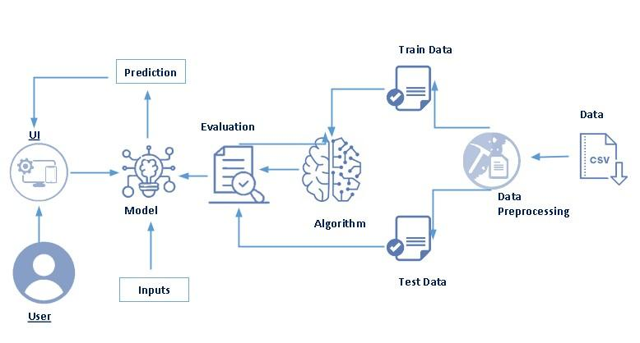

4. PROJECT DESIGN

4.1 PROBLEM SOLUTION FIT
The Problem-Solution Fit in this project focuses on identifying security issues faced by users in online payment systems and developing a machine learning-based solution to effectively detect and prevent fraudulent transactions. It helps in understanding user behaviour, fraud patterns, and system limitations to build a reliable and intelligent fraud detection system.
Purpose:
❑ Solve fraud-related challenges in digital payments by providing a secure and intelligent detection system.
❑ Improve system effectiveness by analysing user behaviour and transaction patterns in real-time.
❑ Enhance communication through timely alerts and notifications for suspicious transactions.
❑ Increase user trust by preventing financial losses and ensuring safe transactions.
❑ Understand existing fraud detection limitations and improve them using machine learning techniques for better accuracy and performance.
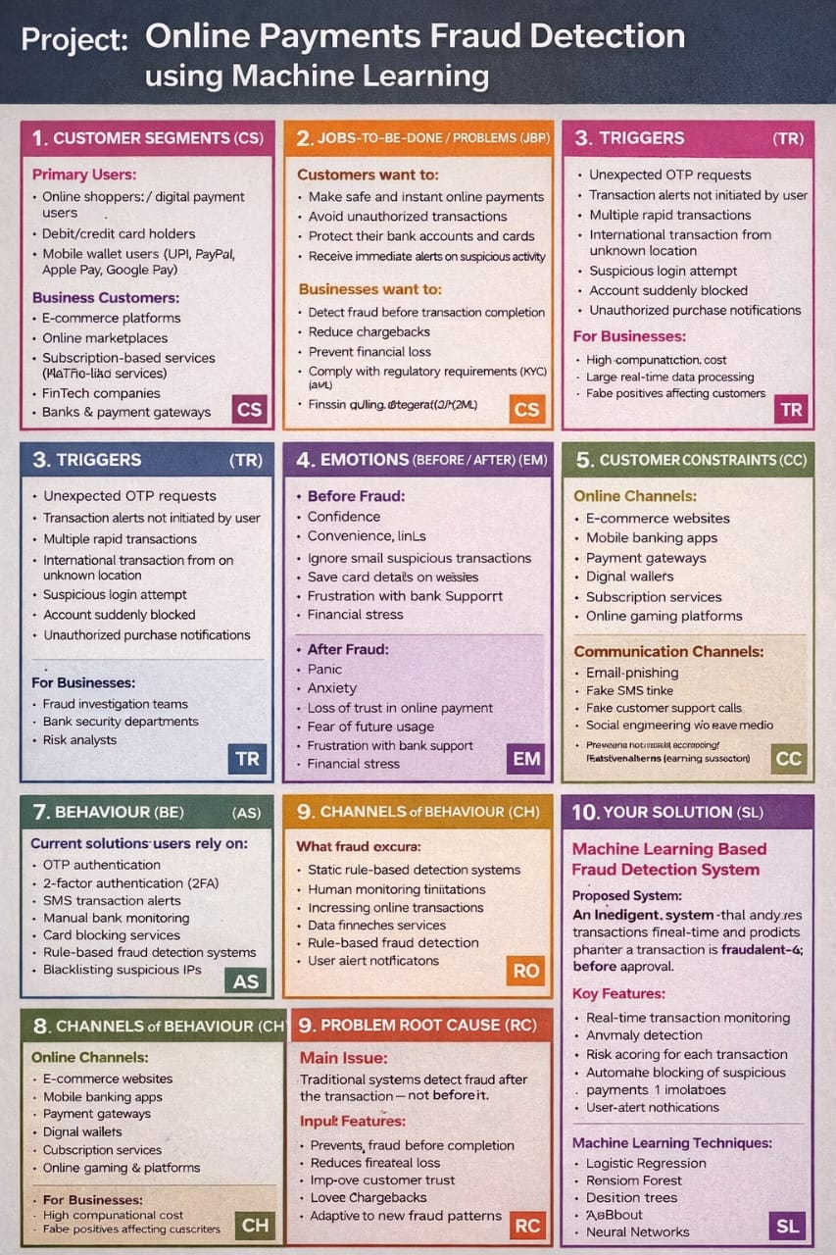

4.2 PROPOSED SOLUTION

The system uses Machine Learning algorithms to detect fraudulent online transactions in real time. It collects and processes transaction data such as amount, location, and user behavior, and analyzes it to identify suspicious patterns. Based on the risk level, the system either approves the transaction, requests additional verification (like OTP), or blocks it. It also sends instant alerts to users and continuously improves its accuracy using past transaction data.
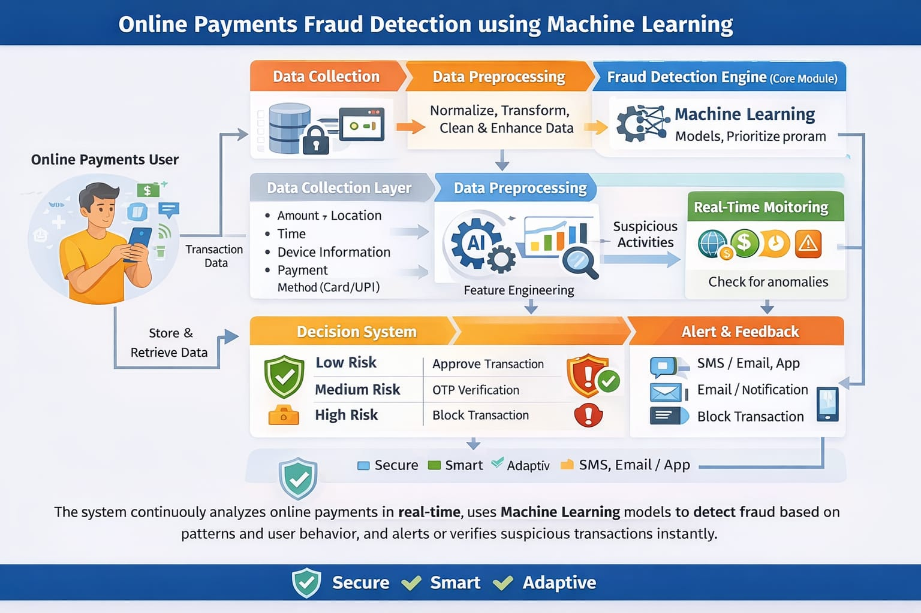
The proposed system uses Machine Learning algorithms to detect and prevent fraudulent online transactions in real time. It collects transaction data such as amount, location, time, and user behavior, and processes it to identify unusual patterns. The system analyzes each transaction using trained models and assigns a risk score. Based on this score, the transaction is either approved, verified using OTP, or blocked to prevent fraud. Additionally, the system sends real-time alerts to users and continuously improves its performance by learning from past transaction data and user feedback.

4.3 SOLUTION ARCHITECTURE
Solution Architecture:
Solution architecture in this project focuses on bridging the gap between online payment security challenges and machine learning-based fraud detection solutions. It defines how different components of the system work together to detect and prevent fraudulent transactions effectively.
Its goals are to:
● Identify the most suitable machine learning techniques to detect fraudulent transactions in online payment systems.
● Describe the structure and working of the system, including user interface, backend processing, fraud detection model, and database to stakeholders.
● Define key features such as real-time transaction monitoring, fraud classification, alert mechanisms, and model training phases.
● Provide clear specifications for developing, managing, and deploying a secure and scalable fraud detection system.
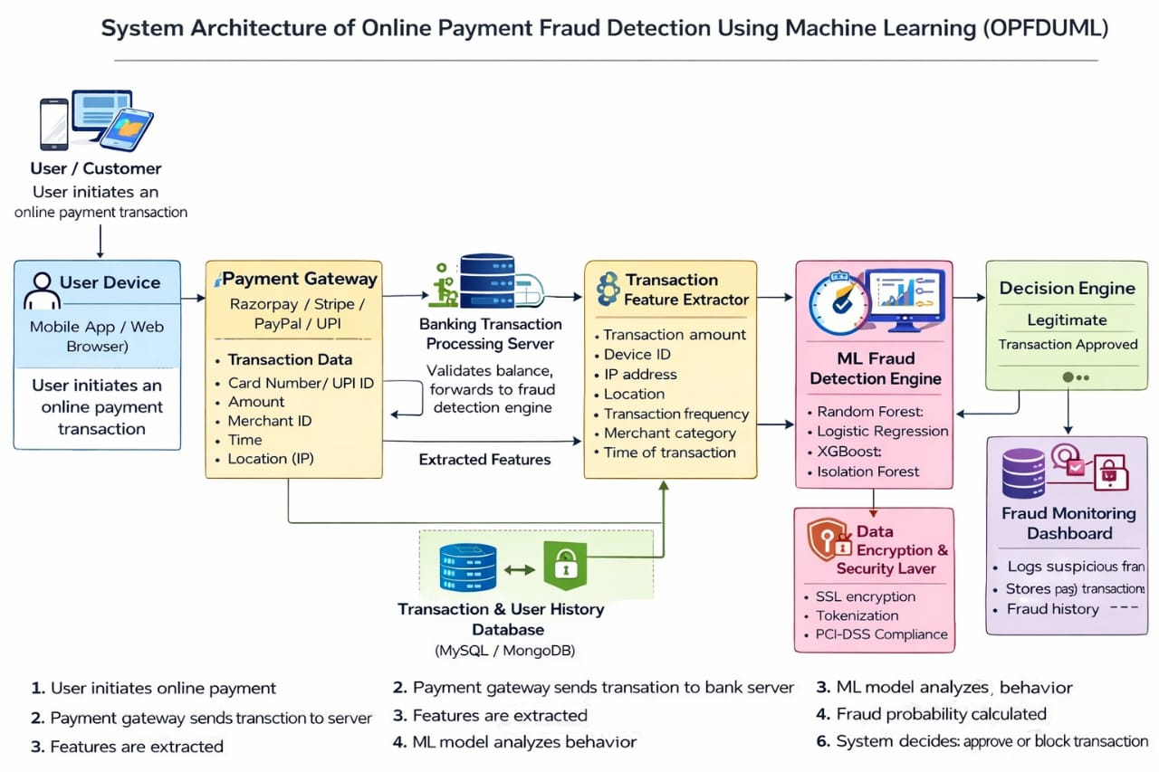

5. PROJECT PLANNING
&
SCHEDULING

5.1 PROJECT PLANNING

Sprint | Functional Requirement (Epic) | User Story Number | User Story / Task | Story Points | Priority | Team Members
Sprint-1 | Registration | USN-1 | As a user, I can register using email & password | 2 | High
Sprint-1 |  | USN-2 | As a user, I receive confirmation email after registration | 1 | High
Sprint-1 | Login | USN-3 | As a user, I can login using email & password | 2 | High
Sprint-1 |  | USN-4 | As a user, I can reset password using OTP | 2 | Medium
Sprint-1 | Dashboard | USN-5 | As a user, I can view transaction details | 2 | High
Sprint-2 | Payment Processing | USN-6 | As a user, I can initiate online payment | 3 | High
Sprint-2 |  | USN-7 | System captures transaction details (amount, device, location) | 3 | High
Sprint-2 | Fraud Detection | USN-8 | System analyzes transaction using ML model | 5 | High
Sprint-2 |  | USN-9 | System classifies transaction as fraud or legitimate | 3 | High
Sprint-3 | Alerts | USN-10 | User receives fraud alert notification | 2 | High
Sprint-3 |  | USN-11 | User receives success notification for valid transactions | 1 | High
Sprint-3 | Database | USN-12 | Store transaction data securely | 3 | High
Sprint-4 | Admin Panel | USN-13 | Admin monitors suspicious transactions | 3 | Medium
Sprint-4 |  | USN-14 | Admin generates fraud reports | 2 | Medium
Sprint-4 | Model Improvement | USN-15 | System updates ML model with new data | 4 | Medium

Project Tracker, Velocity & Burndown Chart: (4 Marks)

Sprint | Total Story Points | Duration | Sprint Start Date | Sprint End Date (Planned) | Story Points Completed | Sprint Release Date
Sprint-1 | 20 | 6 Days | 15 Feb 2026 | 20 Feb 2026 | 20 | 20 Feb 2026
Sprint-2 | 20 | 6 Days | 22 Feb 2026 | 27 Feb 2026
Sprint-3 | 20 | 6 Days | 01 Mar 2026 | 06 Mar 2026
Sprint-4 | 20 | 6 Days | 08 Mar 2026 | 13 Mar 2026

Velocity:
Assuming:
- Sprint Duration = 6 days
- Story Points per Sprint = 20👉 Velocity (AV) = 20 / 6 = ~3.3 story points per day

Burndown Chart:
A burn down chart is a graphical representation of work left to do versus time. It is often used in agile software development methodologies such as Scrum. However, burn down charts can be applied to any project containing measurable progress over time.

6. FUNCTIONAL AND PERFORMANCE TESTING

FUNCTIONAL TESTING

Functional testing verifies whether the system performs according to the specified requirements.
🔹 1. Model Prediction Testing
- Verify that the system correctly classifies transactions as Fraudulent or Legitimate.
- Test using:
  - Valid transaction data
  - Known fraud cases
  - Edge cases (large amounts, unusual locations)
🔹 2. Input Validation Testing
- Ensure system handles:
  - Missing fields
  - Invalid formats (wrong card number format)
  - Negative or extremely large transaction amounts
- Check that proper error messages are generated.
🔹 3. Feature Processing Testing
- Validate:
  - Data preprocessing (scaling, encoding)
  - Handling of null values
  - Feature transformation accuracy
🔹 4. Database Integration Testing
- Confirm:
  - Transactions are stored correctly
  - Fraud flags are updated properly
  - Logs are maintained
🔹 5. Alert & Notification Testing
- Ensure alerts are triggered when fraud probability exceeds threshold.
- Verify notification delivery to admin or monitoring system.
🔹 6. API Testing (If Applicable)
- Test API endpoints:
  - Transaction submission
  - Fraud prediction response
  - Status checks
- Verify response time and correctness of JSON outputs.

PERFORMANCE TESTING:
Performance testing ensures the system performs efficiently under different workloads.
🔹 1. Accuracy Metrics Testing
Evaluate model performance using:
- Accuracy
- Precision
- Recall
- F1-Score
- ROC-AUC Score
- Confusion Matrix
These metrics ensure the model minimizes false positives and false negatives.
🔹 2. Load Testing
- Simulate thousands/millions of transactions.
- Check system stability under high traffic.
- Measure:
  - Throughput
  - Response time
  - Failure rate
3. Stress Testing
- Push system beyond expected load.
- Identify breaking point.
- Monitor:
  - System crashes
  - Memory usage
  - CPU utilization
🔹 4. Latency Testing
- Measure real-time prediction speed.
- Ensure fraud detection occurs within milliseconds.
🔹 5. Scalability Testing
- Test system performance when:
  - Adding more users
  - Increasing transaction volume
- Evaluate horizontal and vertical scaling capability
🔹 6. Model Drift Testing
- Monitor model performance over time.
- Detect decline in accuracy due to changing fraud patterns.
- Trigger retraining when necessary

7. RESULTS

7.1 OUTPUT SCREENSHOTS

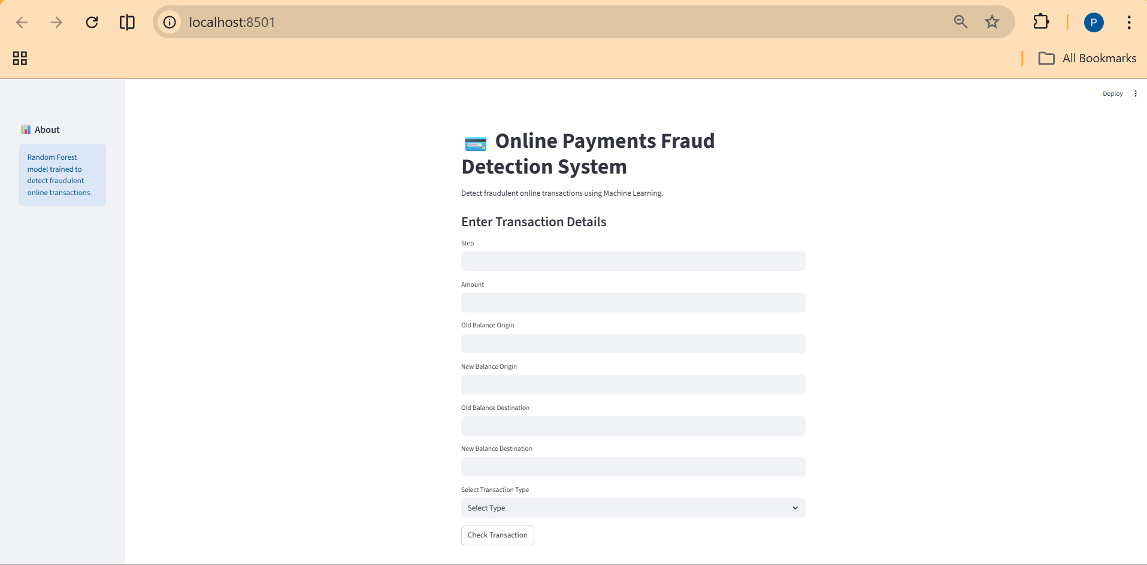

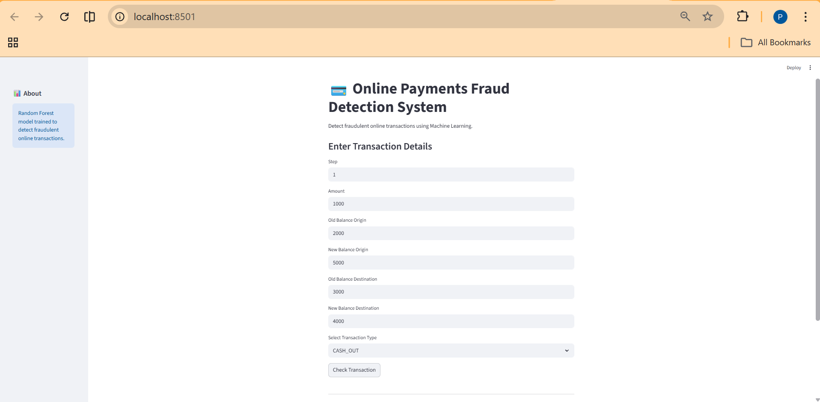

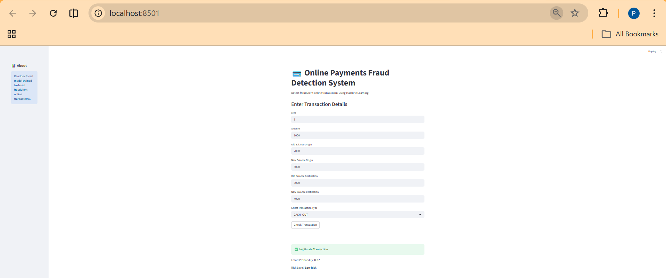

8. ADVANTAGES
&
DISADVANTAGES

ADVANTAGES:
1. Real-Time Detection
ML models can analyse transactions instantly and flag suspicious activity within milliseconds, reducing financial loss.
2. High Accuracy with Pattern Recognition
ML can detect complex patterns and subtle anomalies that rule-based systems might miss, including:
- Unusual spending behaviour
- Location inconsistencies
- Device fingerprint anomalies
3. Continuous Learning
Models improve over time by learning from new fraud patterns, adapting to evolving tactics used by fraudsters.
4. Reduced Manual Review
Automation reduces the need for human intervention, saving time and operational costs.
5. Scalability
ML systems can handle millions of transactions per second, making them suitable for global payment networks.6. Lower False Positives (When optimized)
Advanced ML models can better distinguish between legitimate and fraudulent transactions, improving customer experience.

DISADVANTAGES:
1. Requires Large, High-Quality Data
ML models need vast datasets to train effectively. Poor-quality or biased data reduces performance.
2. False Positives Still Occur
Even strong systems may:
- Block legitimate transactions
- Frustrate customers
- Cause revenue loss
3. Model Bias & Fairness Issues
If training data is biased, models may unfairly flag certain user groups more frequently.
4. High Implementation Cost
Developing, training, deploying, and maintaining ML systems requires:
- Skilled data scientists
- Infrastructure
- Continuous monitoring
5. Adversarial Attacks
Fraudsters adapt their methods to bypass ML systems, including:
- Testing small transactions
- Mimicking legitimate behaviour patterns
6. Lack of Explainability
Some ML models (e.g., deep learning) act as "black boxes," making it hard to explain why a transaction was flagged — which can be problematic for regulatory compliance.

9. CONCLUSION

CONCLUSION:

Online payment fraud detection using Machine Learning (ML) provides an intelligent, scalable, and adaptive solution to combat financial fraud in digital transactions. Unlike traditional rule-based systems, ML models can analyse vast amounts of transactional data in real time, detect hidden patterns, and continuously improve as fraud tactics evolve. This approach enhances security, reduces financial losses, and improves customer trust for digital payment platforms such as PayPal, Visa, and Mastercard. However, challenges like data dependency, false positives, model bias, and explainability must be carefully managed. Overall, ML-based fraud detection systems are highly effective and essential in today’s fast-growing digital payment ecosystem.

10. FUTURE SCOPE

FUTURE SCOPE:

The future scope of this project is vast due to increasing online transactions and evolving cyber threats. Some key areas of future enhancement include:
1. Integration of Deep Learning
Using advanced deep learning models (e.g., LSTM, neural networks) to improve detection accuracy for complex fraud patterns.
2. Real-Time AI with Edge Computing
Deploying fraud detection models closer to transaction sources for faster decision-making and reduced latency.
3. Explainable AI (XAI)
Developing transparent ML models that provide clear reasons for flagged transactions to meet regulatory requirements.
4. Blockchain Integration
Combining ML with blockchain technology to enhance transaction transparency and reduce fraud risks.
5. Behavioural Biometrics
Incorporating user behaviour patterns such as typing speed, device usage, and touch dynamics for stronger authentication.
6. Adaptive & Self-Learning Systems
Creating fully automated systems that update themselves with minimal human intervention.
7. Federated Learning
Allowing multiple financial institutions to collaboratively improve fraud detection models without sharing sensitive customer data.

11.APPENDIX

SOURCE CODE

online-payments-fraud-detection-using-ml

DATASET LINK

https://www.kaggle.com/datasets/rupakroy/online-payments-fraud-detection-dataset

GITHUB & PROJECT DEMO LINK

GitHub:
https://github.com/VaishnaviSravanthi/Online-Payments-Fraud-Detection-Using-Machine-Learning

Demo Link:

https://drive.google.com/file/d/1gfaQ4aOHBojAqMZbbryg-kmPfVqwQWUX/view

